Bexley Elementary School PTO Spirit Wear!
2022-2023
Support our PTO with BEXLEY ELEMENTARY SPIRIT WEAR!

- T- Shirts (variety of sizes, colors, and styles) $15.00
- Water Bottles- $10.00
- Scrunchies- $6.00
- Lanyard- $6.00
- Car Magnet- $8.00
- Bexley Pencil- $1.00
- Hand Sanitizer- $4.00

Cash or Check only please – Payable to Bexley Elementary School- all checks require a telephone number, a student ID#, and student name.
Online Boutique opportunities will be available during the school year. Prices and Spirit Wear choices may vary with each online boutique.

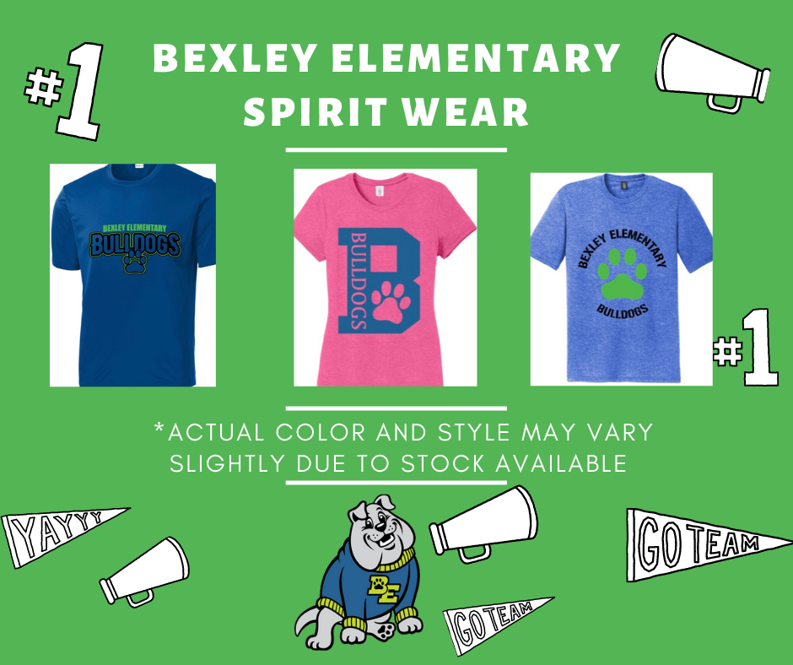

Bexley Spirit Days are Fridays! Let’s show our BULLDOG SPIRIT!

