Anything w beach and home improvement

Macy’s, Ross, Marshalls

Bone Fish, Carrabba’s Italian Grill, Outback steakhouse

Iced coffee w hazelnut creamer only

rose

rose

Diet dr pepper, coffee

Red or teal

Burgers, Pizza, Pasta, Seafood, Doritos cool ranch, snickers, reese’s pieces candy

7 1/2

12-25-72

C

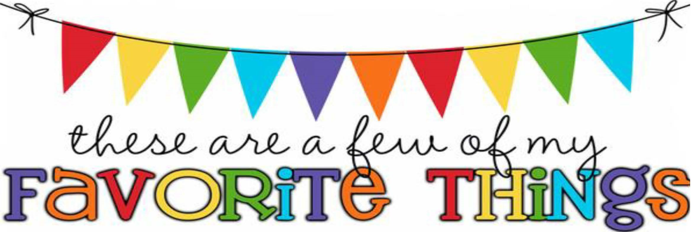

**Monogram:**

**Birthday:**

**Shoe Size:**

**Food**

&

**Candy:**

**Color:**

**Drink:**

**Flower:**

**Scent (lotion):**

**Dunkin'**

**Drink:**

**Restaurants:**

**Sports Team:**

**Stores:**

**Hobbies:**

**Items I need for the classroom: NA**