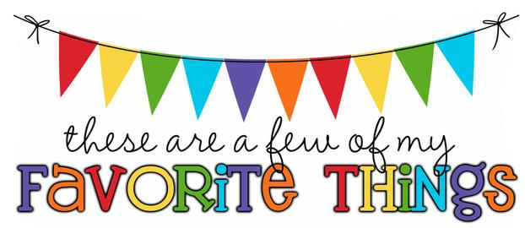

Mrs. Brown 1st Grade
Birthday: October 22nd
Shoe Size: 7.5
Food & Candy: peanut butter anything, pumpkin spice anything, white cheddar popcorn, Swedish fish, Combos, Pringles, Fruit, Twizzlers, Almond Joys
Color: navy blue, purple, brown, forest green (earthy colors)
Drink: coffee (pumpkin, caramel, vanilla), orange or grape soda, strawberry lemonade, orange Gatorade
Flower: sunflowers and daisies Scent (lotion): any
Restaurants: Longhorn, Chili’s, Applebee’s, Chick fil-A, Outback, Olive Garden, Red Lobster, Dunkin, Five Guys, Chipotle, Arby’s, Panera Bread, Starbucks,
Sports Team: Rays and Cubs
Stores: Amazon, Kohl’s, Target, Hobby Lobby, Burlington Coat Factory, Earthbound Trading Co., Ross, Publix, TJ Maxx
Author: Any children’s books
Hobbies: jogging, painting rocks, playing with my own children, Karaoke, canvas painting, photography
Items I need for the classroom: printer ink (Canon brand - 240XL black ink and 241XL color ink), magic erasers, 1-inch white binders, 2.5-gallon Ziploc bags, small treasure box items, kid books, clipboards
THANK YOU SO MUCH!

