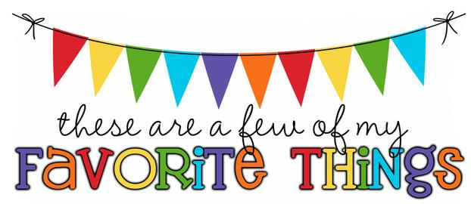

Monogram: HME

Birthday: July 12th

Food & Candy: Sweet Tarts, Skittles, Whoppers (who am I kidding…I LOVE candy!!)

Color: burgundy, seafoam green, black

Drink: Fruit punch Crystal Lite

Flower: Roses and Sunflowers

Scent (lotion): Clean or fruity

Starbucks Drink: None

Restaurants: Chick-fil-A, Carabbas, Melting Pot

Stores: Target, Marshalls, Home Goods

Author: I do not have a favorite author but I love to read. I can spend hours in Books-A-Million.

Hobbies: Hiking, Biking (anything outdoors)

Items I need for the classroom: Treasure Box items

