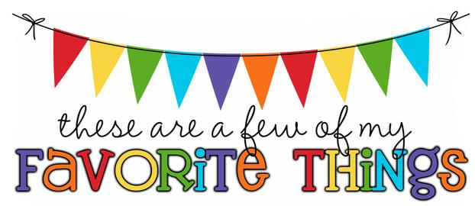

Monogram: EKD (Emily Donnery) -3rd Grade
Birthday: June 25th
Food & Candy: Dark Chocolate
Color: Turquoise, Teal
Drink: Green Tea/Coffee
Flower: Sunflowers/Tulips
Scent (lotion): Sweet
Starbucks Drink: Frappucino
Restaurants: Bonefish, Carrabbas
Sports Team: Bucs
Stores: TJMAX, Target, Homegoods, Ross
Hobbies: Boating, Beaching, Fishing
Items I need for the classroom: Treasure Box Items

