Bexley Elementary
Kindergarten Supply List, 2021-2022

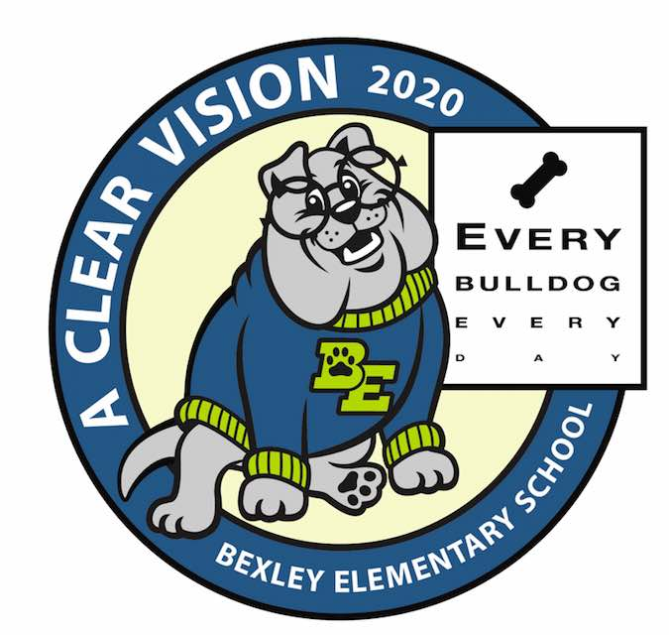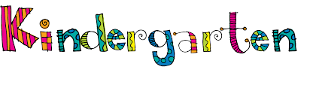
***You may drop your supplies off at meet the teacher on August 5th

1 lanyard (label with your child’s first and last name)
1 pack of 12 pre-sharpened pencils (#2)
4 boxes of 24 count Crayola crayons
1 pack of 4 count black EXPO dry erase markers
1 pair sharp point Fiskar’s brand scissors
8 Elmer’s purple glue sticks
2 packages of white copy paper
2 package of colored copy paper, 1 pastel or 1 neon (girls purchase)
1 package of white cardstock (boys purchase)
2 packs of 3x5 index cards
1 pair of headphones with straight adaptor (label with your child’s
first and last name)
1 8” x 12” personal whiteboard
White 3 ring binder 0.5 inch capacity with clear front and back sleeves.
1 bottle of hand sanitizer
1 box of gallon size Zip Lock baggies with sliders
1 box of sandwich size Zip Lock baggies with sliders
1 box of tissues

Optional classroom wish list
*Scotch thermal 3x laminating sheets
*Stickers
*Shaving cream
*Playdough
*Additional colored cardstock

Your child's teacher may request specific items for their individual classroom.

