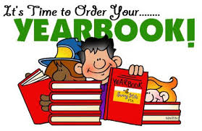
Pre-Order 2/8/21-2/26/21

THE BEXLEY ELEMENTARY YEARBOOK!

Pre-Sale Pricing: $20.00*

*Must be purchased before 2/26/21

You may purchase yearbooks online by using the Rycor site www.studentquickpay.com/pasco

Please submit the form below after completion of online payment.

Student Name: _____________________________ Student ID# ____________________

Teacher’s Name: ____________________________ Grade: ________________________

Parents Name: _____________________________ Phone # _______________________

Yearbook price will go up to $30.00 when purchased between 3/1/21 - 5/21/21. They will be sold on a first come-first served basis. There will be limited availability after the pre-sales, please pre-purchase to aid in accurate counts so all can receive a yearbook who wish to purchase one.

Pre-Order 2/8/21-2/26/21

THE BEXLEY ELEMENTARY YEARBOOK!

Pre-Sale Pricing: $20.00*

*Must be purchased before 2/26/21

You may purchase yearbooks online by using the Rycor site www.studentquickpay.com/pasco

Please submit the form below after completion of online payment.
Student Name: _____________________________ Student ID# ____________________

Teacher’s Name: ____________________________ Grade: ________________________

Parents Name: _____________________________ Phone # _______________________

Yearbook price will go up to $30.00 when purchased between 3/1/21 - 5/21/21.

They will be sold on a first come-first serve basis. There will be limited availability after the pre-sales, please pre-purchase to aid in accurate counts so all can receive a yearbook who wish to purchase one.

